DataBase

MySQL
Relational database ( Related data in a table and they are tied to other table ). This is free & open source. This is compatible with MariaDB ( made by MySQL original creator ) and Amazon Aurora.

Example)
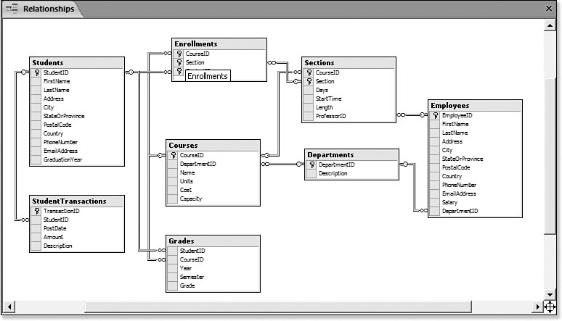

How to install
https://bitnami.com/stack/wamp
This is easier way to use MySQL ( according to tutorial )
Bitnami WAMP Stack provides a complete, fully-integrated and ready to run WAMP development environment. In addition to PHP, MySQL and Apache, it includes FastCGI, OpenSSL, phpMyAdmin, ModSecurity, SQLite, ImageMagick, xDebug, Xcache, OpenLDAP, ModSecurity, Memcache, OAuth, PEAR, PECL, APC, GD, cURL and other components and the following frameworks:Zend Framework, Symfony, CodeIgniter, CakePHP, Smarty, Laravel.
Only install MySQL from this bundle. So uncheck everything when installing.

How to run MySQL
Open CMD > Go to Bitnami\wampstack-ver\mysql\bin > ‘mysql –uroot –p’ or ‘mysql –h[MyWebsiteURL].com –p3306’ ex) ‘mysql –hopentutorials.org –p3306 –p’> type password.

How to backup db and Import it
http://localhost.org/phpmyadmin username: root, password: audition****

Basic Commands
List
show databases;

Select database
use [database-name];
show tables;

desc [table-name]; // show description of table

Create a database
CREATE DATABASE o2 CHARACTER SET utf8 COLLATE utf8_general_ci;

(CRUS = Create, Read, Update, Select)
Create a table
CREATE TABLE `testing` (
`id` int(11) NOT NULL AUTO_INCREMENT,
`title` varchar(100) NOT NULL,
`description` text NOT NULL,
`author` varchar(30) NOT NULL,
PRIMARY KEY (id)
) ENGINE=InnoDB DEFAULT CHARSET=utf8;

Insert row into table
INSERT INTO testing (title, description, author) VALUES('JavaScript','Computer language for web.', 'egoing');

for multiful insert

VALUES
('JavaScript','Computer language for web.', 'egoing'),
('JavaScript','Computer language for web.', 'egoing'),
('JavaScript','Computer language for web.', 'egoing');

Select row from table
Select * from testing ; // all
Select * from testing where id=1; // select id 1

Modify data in a row from table
Update testing set title=’npm’ where id=2;

Delete row from table.
Delete from testing where id=2;

Advance Commands
CREATE TABLE users (
id INT NOT NULL AUTO_INCREMENT ,
authId VARCHAR(50) NOT NULL ,
username VARCHAR(30),
hash VARCHAR(255),
salt VARCHAR(255),
displayName VARCHAR(50),
email VARCHAR(50) NOT NULL ,
PRIMARY KEY (id),
UNIQUE (authId)
) ENGINE = InnoDB;

id INT NOT NULL AUTO_INCREMENT , >> Id should not be null and increase number on the largest id number.
UNIQUE (authId) >> If there is already same number authId when app tries to upload, reject inserting it.

